Dr. Slawomir Nowaczyk
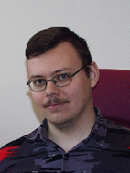dr S.Nowaczyk
Slawomir Nowaczyk, PhD (Slawomir.Nowaczyk@agh.edu.pl, www) holds a position of associate professor in AGH UST in Krakow, Poland, Department of Automatics. He has received his MSc degree from Poznan University of Technology, Poland, in 2002 for a thesis “Decision support based on analytical learning” and his PhD degree from Lund University, Sweden, in 2008 for a thesis “Conditional Partial Plans for Rational Situated Agents Capable of Deductive Reasoning and Inductive Learning”.
He has been one of the lead developers in the SIARAS project, and is also involved in HeKatE and INDECT projects. He is the author of over 20 publications, and his main research interests focus on combining planning, learning and deduction in the setting of rational agents operating in dynamic and partially unknown environments.
His hobbies include sailing, Magic: the Gathering trading card game, bridge, fantasy and science fiction literature.

