GEIST People

Senior Associated Researchers, Full Professors
Grzegorz J. Nalepa  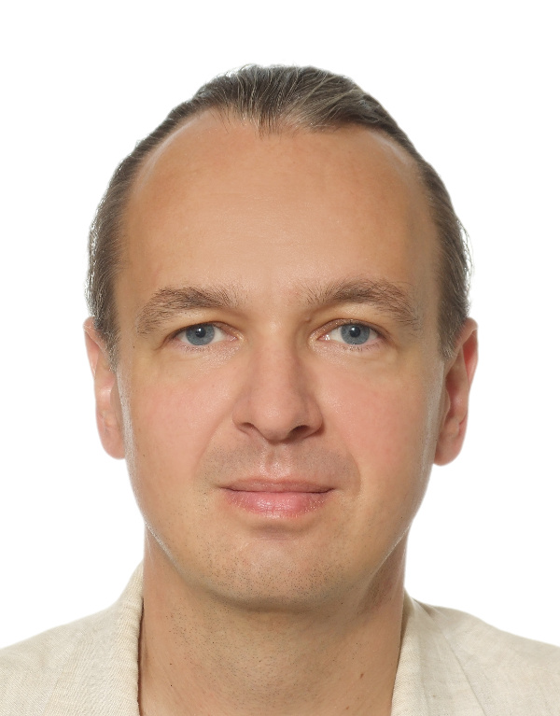  gjn@gjn.re  GJN.re  short bio | Marcin Szpyrka  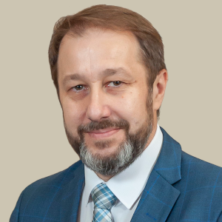  mail  WWW  short bio

Assistant Professors
Szymon Bobek  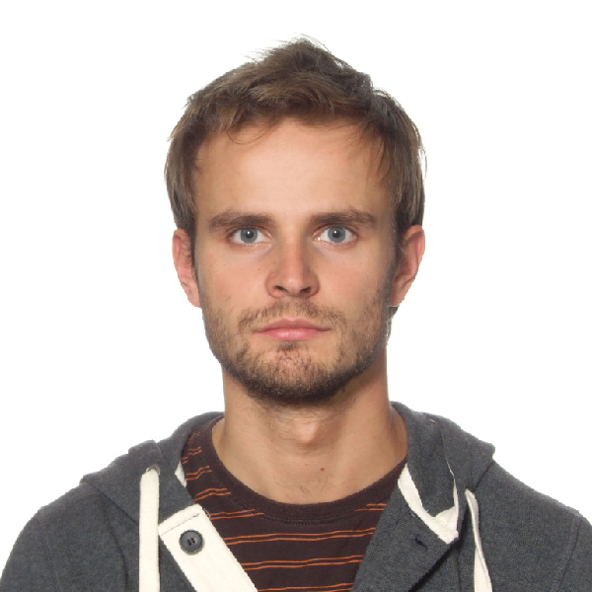  mail  WWW  short bio | Krzysztof Kutt  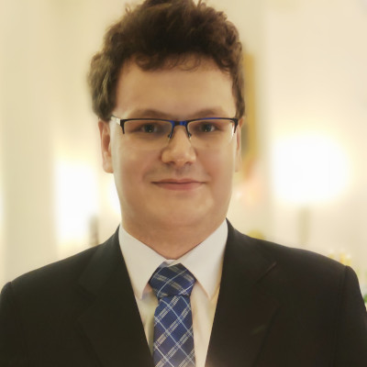  mail  WWW  short bio

PhD Researchers
Jakub Jakubowski  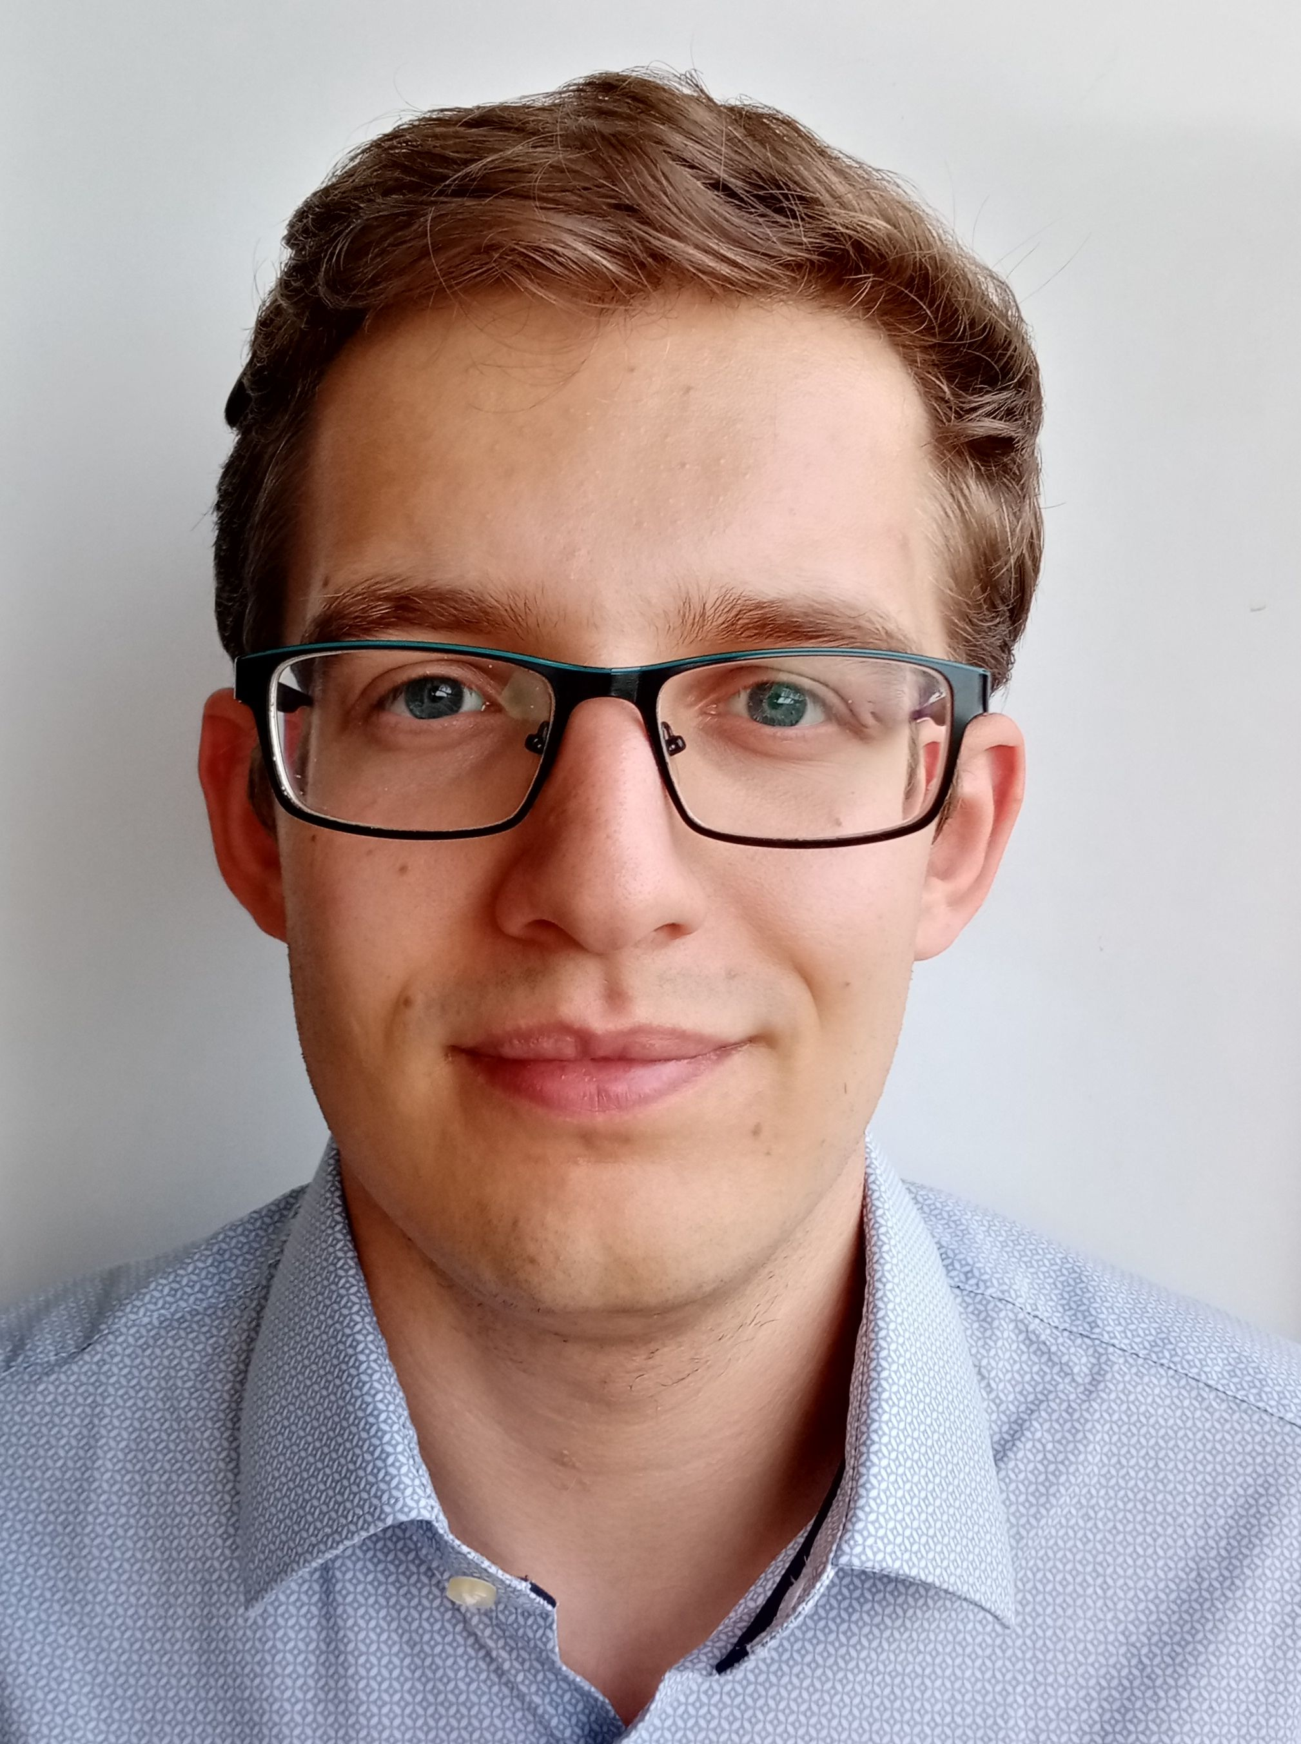  short bio | Michał Kuk  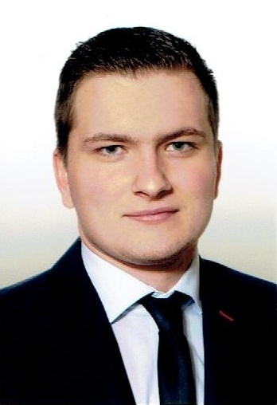  short bio | Bartłomiej Małkus    mail  short bio

Maciej Mozolewski | Maciej Szelążek  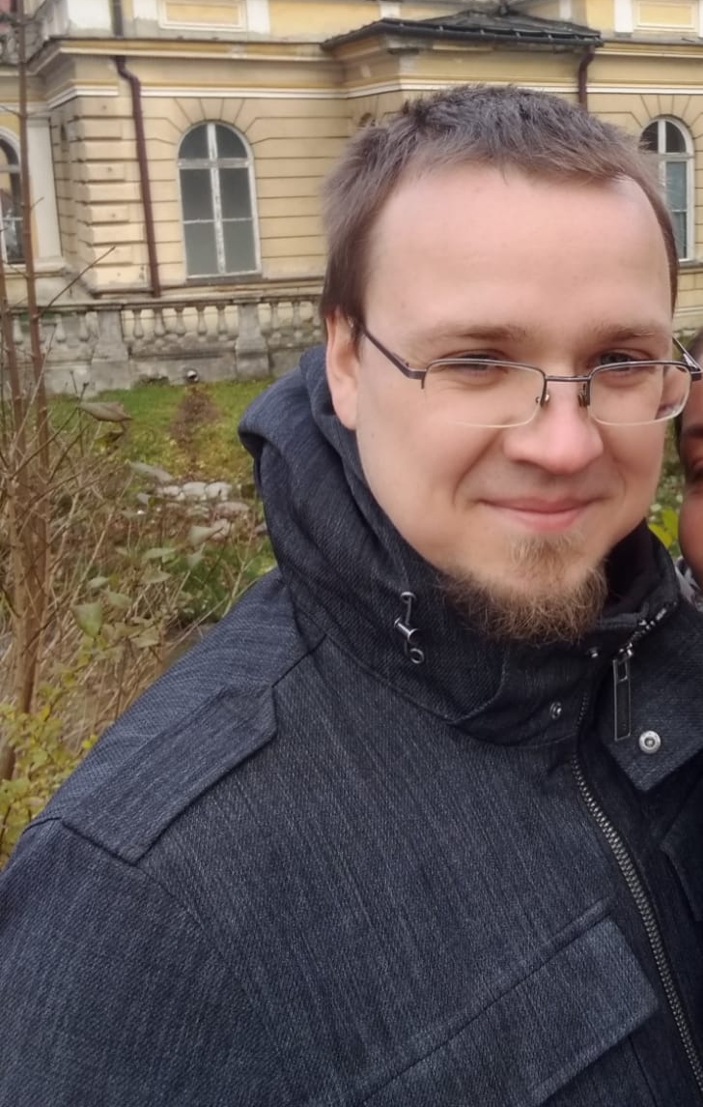  mail  short bio | Mateusz Ślażyński  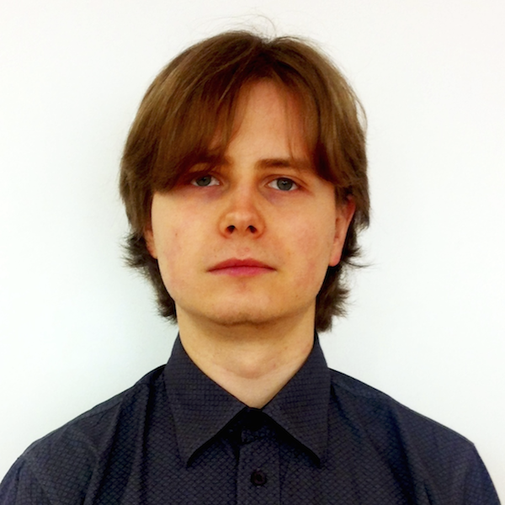  mail  WWW  short bio

Michał Zwierzyński
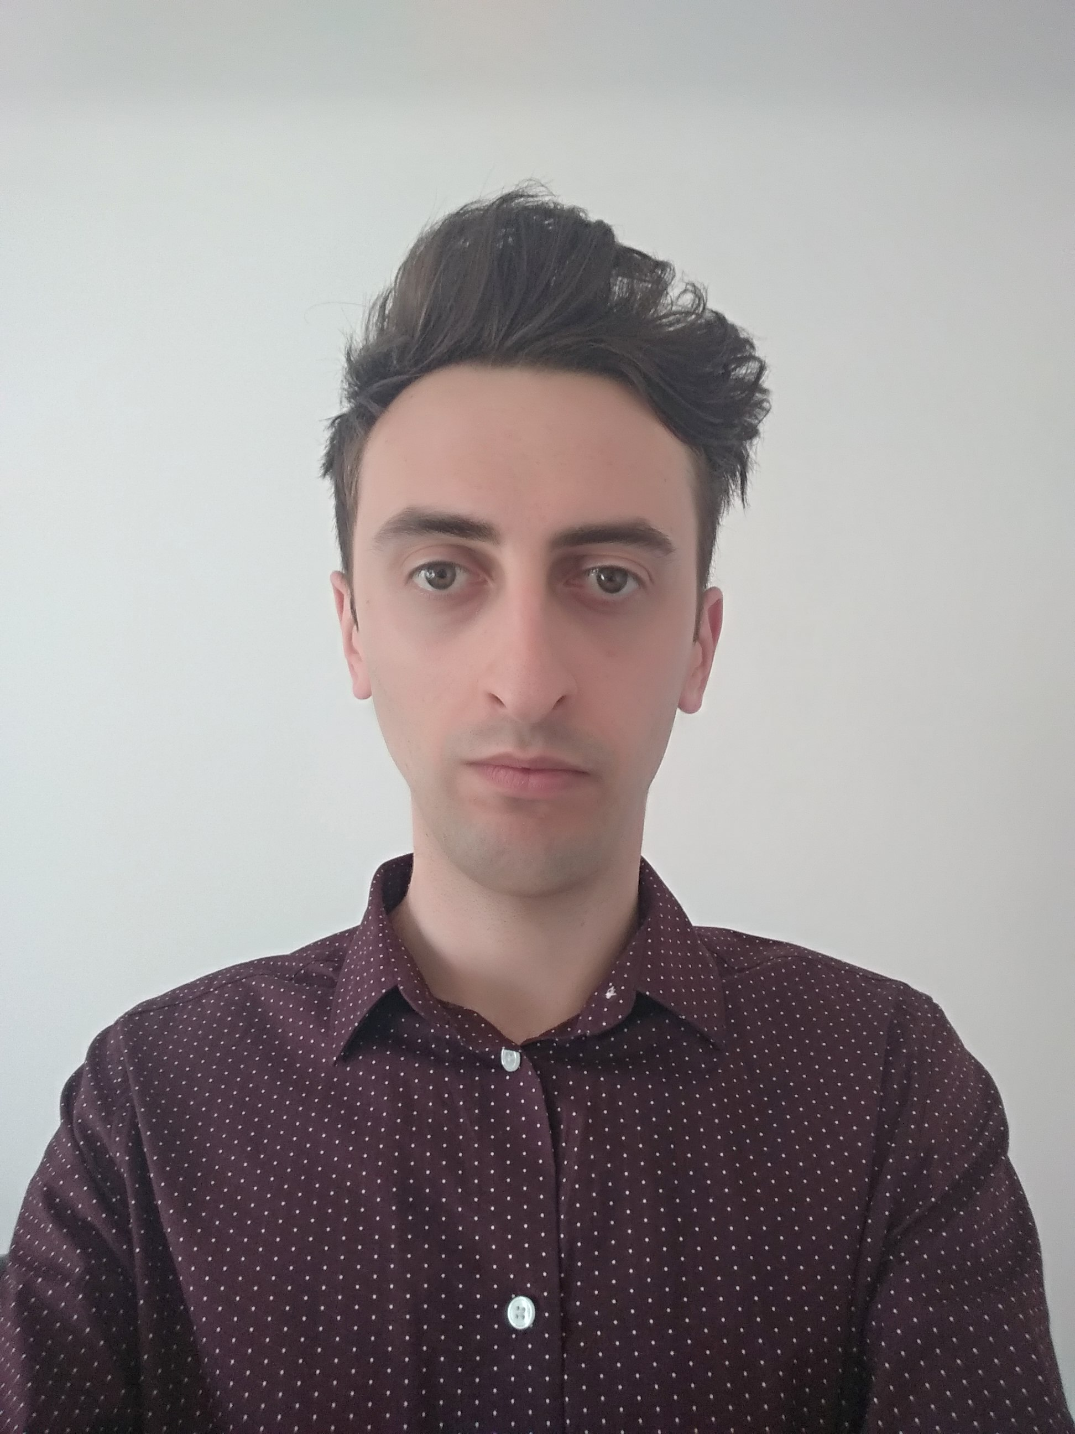
short bio

Guests and Interns
Dominika A. Drążyk    mail  ResearchGate  short bio | Víctor Rodríguez Fernández  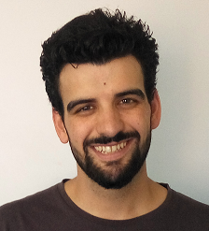  mail  Google Scholar  short bio | Kacper Łodziński  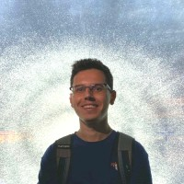  mail  WWW  short bio
Radosław Pałosz  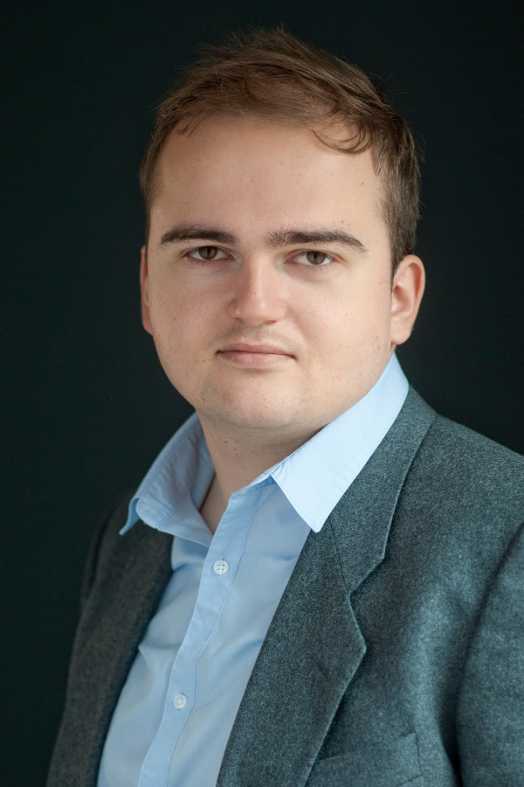  mail  short bio | Przemysław Stanisz  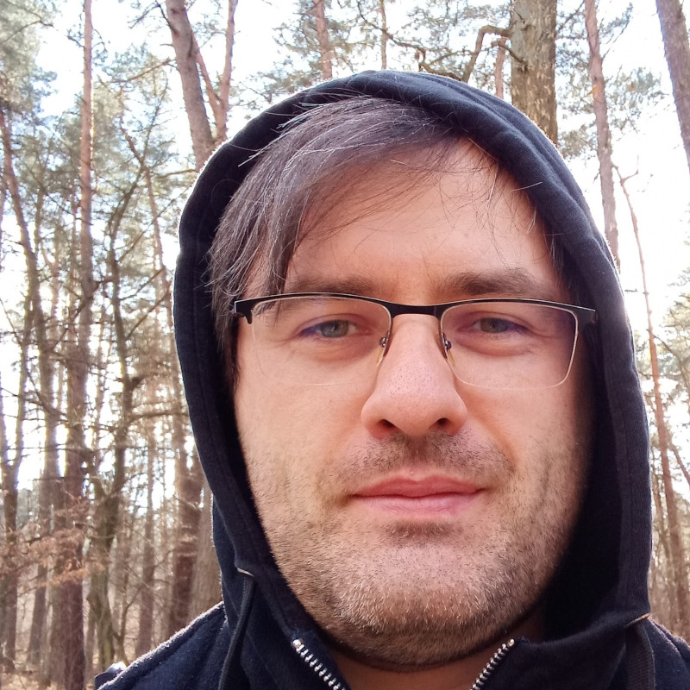  short bio | Laura A. Żuchowska  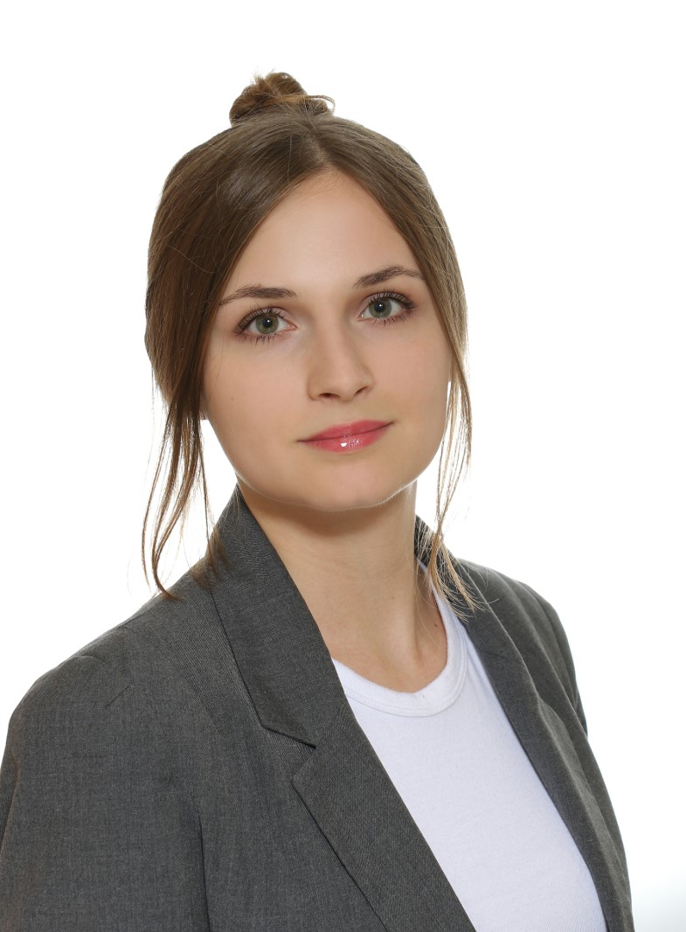  short bio

Hall of Fame: Former/Inactive/Active-Elsewhere Researchers
Antoni Ligęza  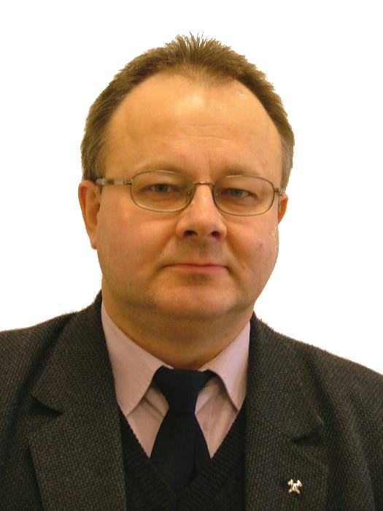  short bio | Sławomir Nowaczyk  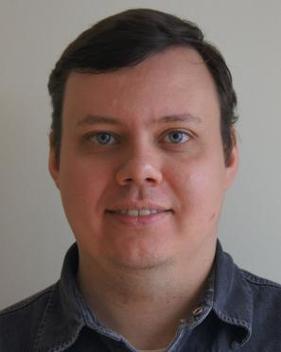  short bio  Now leading lab in Halmstad University, Sweden | Weronika T. Adrian  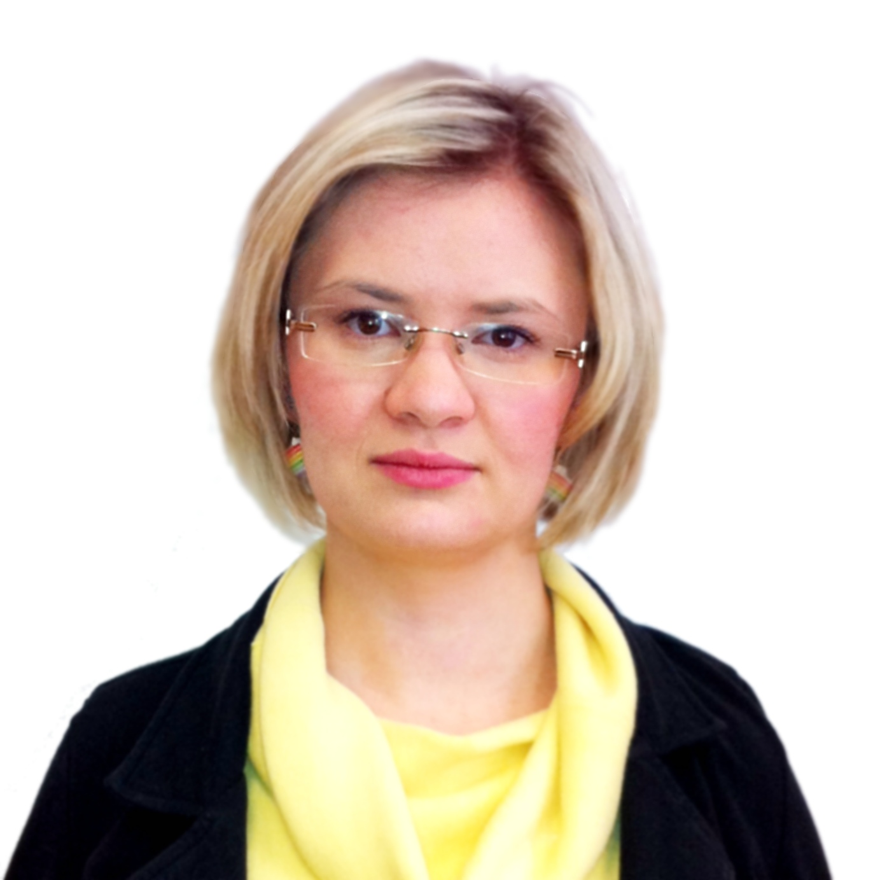  short bio  Now postdoctoral researcher in University of Calabria, Italy

Barbara Giżycka  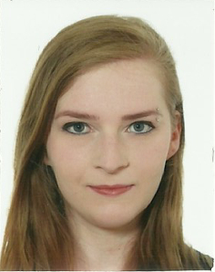  short bio | Paweł Jemioło    short bio | Krzysztof Kaczor    short bio  Gone for the industry.

Krzysztof Kluza  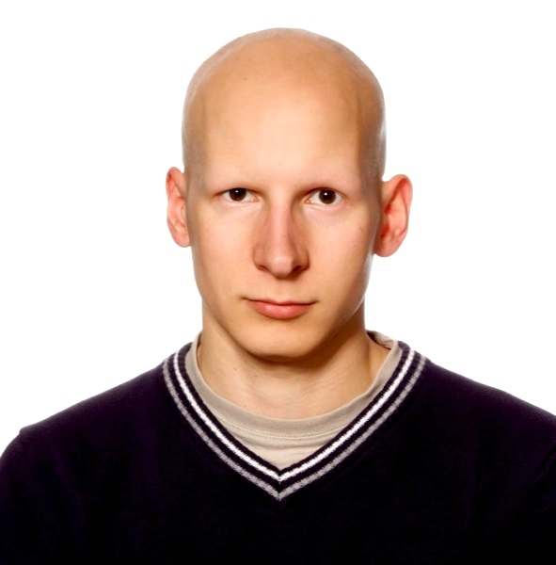  short bio  Lost in the Dean's office | Sławomir K. Tadeja  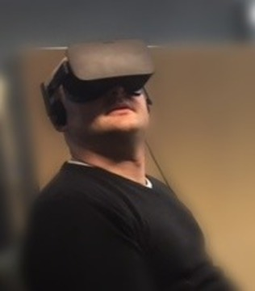  short bio | Michał Wypych    short bio

Selected Former Students
- Olgierd Grodzki
- Rafał Kułaga
- Łukasz Łysik
- Radosław O. Milo
- Piotr Misiak

