Polish Liability Insurance

Description
The Polish Liability Insurance process describes the process, which determines the price for the liability insurance for protecting against third party insurance claims. Because the insurance price is determined based on some data from a user, the first task (Enter car and driver data) requires interaction with a user i.e. entering the input data. Further tasks determine the insurance price: the base price is calculated first, then the calculated insurance premium can be increased or decreased, and finally, all discounts are taken into account and the final price for insurance is calculated.

Model
BPMN Diagram types: Process,
Source files: plli.sgx, plli.bpmn plli-all.pdf
Diagram files: , plli.pdf
plli.svg
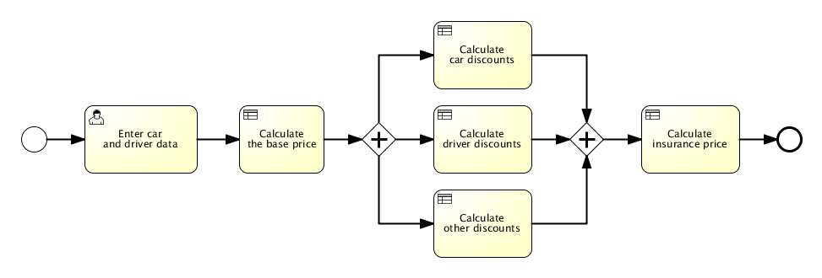Plli Bimloq case BPMN model

Model logic
XTT2 logic model: plli_xtt.hml


