Prosecco
Processes Semantics Collaboration for Companies (Prosecco)

- Grant NCBiR 1. Program Badań Stosowanych, no. PBS1/B3/14/2012
- Project Leader: dr hab. inż. Grzegorz J. Nalepa
- Start time: 01.12.2012
- Duration: 32 months
- Members of consortium:
  - AGH University of Science and Technology - leader,
  - Softhis sp. z o.o.,
  - Poznan University of Technology.
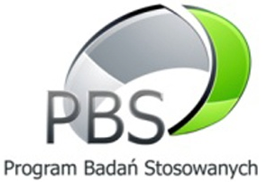
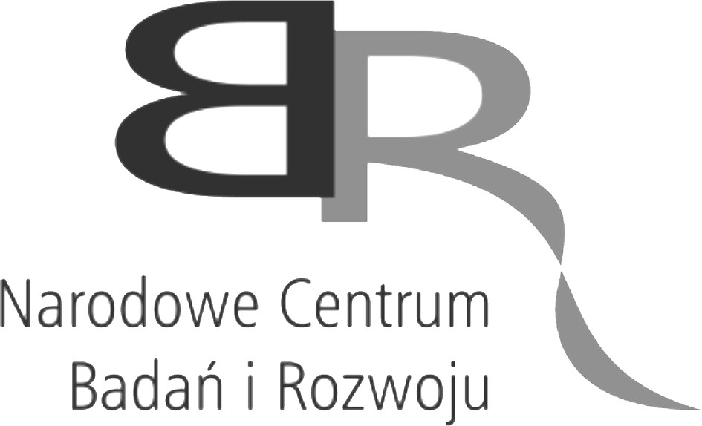


Motivation
Provision of Business Process Management (BPM) systems is an important activity of the main IT vendors. However, such systems are dedicated mainly for large companies, organizations and agencies. The goal of the project is to address the needs and constraints of small and medium enterprises (SME) by designing methods that will significantly improve BPM systems on the basis of the participants' former research.

Intended results
The project will elaborate solutions that enhance the IT system of Softhis Ltd. (SME, which is one of the project partners) using intelligent technologies from the areas such as Semantic Web, Business Process Modeling, Business Intelligence and Machine Learning. The aim is to simplify the design and configuration of BPM systems, targeting the management quality and competitiveness improvement, fostering decisions making and strategic planning in the SME market sector. It is assumed that the goal will be reached by:
- Development of business process modeling methods taking the semantic dependencies between diagram elements and data into account.
- Development of ontology-based mechanisms allowing for creating taxonomies of process concepts and system objects.
- Using recommendation algorithms for analysis of semantically described business process models.

Abstract
Provision of Business Process Management (BPM) systems is an important activity of the main IT vendors. However, such systems are dedicated mainly for large companies, organizations and agencies. The goal of the project is to address the needs and constraints of small and medium enterprises (SME) by designing methods that will significantly improve BPM systems on the basis of the participants' former research. In particular, the project will elaborate solutions that enhance the IT system of Softhis Ltd. (SME, which is one of the project partners) using intelligent technologies from the areas such as Semantic Web, Business Process Modeling, Business Intelligence and Machine Learning. The aim is to simplify the design and configuration of BPM systems, targeting the management quality and competitiveness improvement, fostering decisions making and strategic planning in the SME market sector.
tag>project current_project
Go to → projects
Go to → internal site for AGH team

